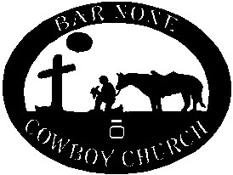
Bar None Winter Series Cattledog Trial
44 Arrowleaf Lane
Mountain Home, AR

Saturday, February 3, 2018
Saturday, February 17, 2018
Saturday March 3, 2018

Open Handlers’ Meeting at 7:45 a.m.
Hosted by Randy Mooney 870-421-0165

NCA & CCA Sanctioned

$30 entry fee for all classes. No payback

Open class limited to 20 entries per day

Series cumulative combined championship buckles for all classes

Class order: Open, Nursery, Pronovice, Intermediate, Novice
All classes will run on the indoor arena only.

Call or text entries to Gerry Knipmeyer 918-914-1778

