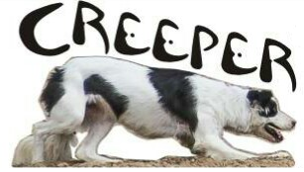
Cattledog Trial Series

Parsons State Hospital Zimmerman Family Arena
2601 Gabriel Street
Parsons Kansas, 67357

Hosted by Creeper Border Collies, Sonny Mahurin and Family

Series dates February 24 and March 24, 2018

Open handlers meeting @ 8 am each day.

Call Sonny Mahurin 620-305-8164 with entries and pay day of the trial
Total entries limited to 70 runs per day

Open $75, Nursery $75, Intermediate $65, Pronovice $65, Novice $55

Series combined awards for each class

NCA and CCA Sanctioned

